A rough guide to
compiling a
Reference list
using
Microsoft Word

DRAFT

This document is written as a guide only – there are lots of different places on the Internet that you can use to convert references into APA format. Also, Word doesn’t have the answer to all of our referencing needs – there are some areas that you need to modify by hand.
There is one certainty – referencing drives nearly everyone crazy.
It sometimes takes as long to add in the references as it does to write the essay – so remember to allow enough time!!

What is Citation?

A “citation” is the way you tell your readers that certain material in your work came from another source. It also gives your readers the information necessary to find that source again, including:

information about the author

the title of the work

the name and location of the company that published your copy of the source

the date your copy was published

the page numbers of the material you are using

Why should I cite sources?

Giving credit to the original author by citing sources is the only way to use other people’s work without plagiarizing. But there are a number of other reasons to cite sources:
- Citations are extremely helpful to anyone who wants to find out more about your ideas and where they came from.
- Not all sources are good or right – your own ideas may often be more accurate or interesting than those of your sources. Proper citation will keep you from taking the rap for someone else’s bad ideas.
- Citing sources shows the amount of research you’ve done.
- Citing sources strengthens your work by lending outside support to your ideas.

Doesn’t citing sources make my work seem less original?

Not at all. On the contrary, citing sources actually helps your reader distinguish your ideas from those of your sources. This will actually emphasize the originality of your own work.

When do I need to cite?
Whenever you borrow words or ideas, you need to acknowledge their source. The following situations almost always require citation:
- Whenever you use quotes
- Whenever you paraphrase
- Whenever you use an idea that someone else has already expressed
- Whenever you make specific reference to the work of another
- Whenever someone else’s work has been critical in developing your own ideas.

This page provided by Turnitin.com and Research Resources. Turnitin allows free distribution and non-profit use of this document in educational settings.
To compile a reference list
Open Microsoft Word
Click on references

Under style, select APA Sixth Edition

To add items to your list, click on Manage Sources. The source manager box pops up.
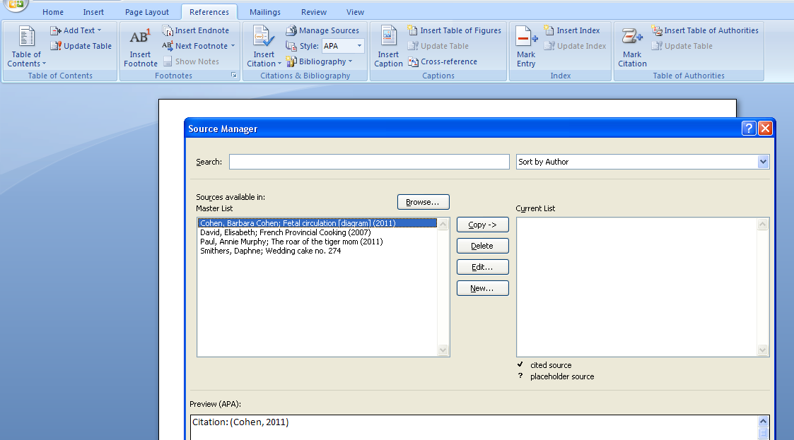

Click on new…. Using the Type of Source field, click on the drop down box to select the type you need eg book, Journal Article.
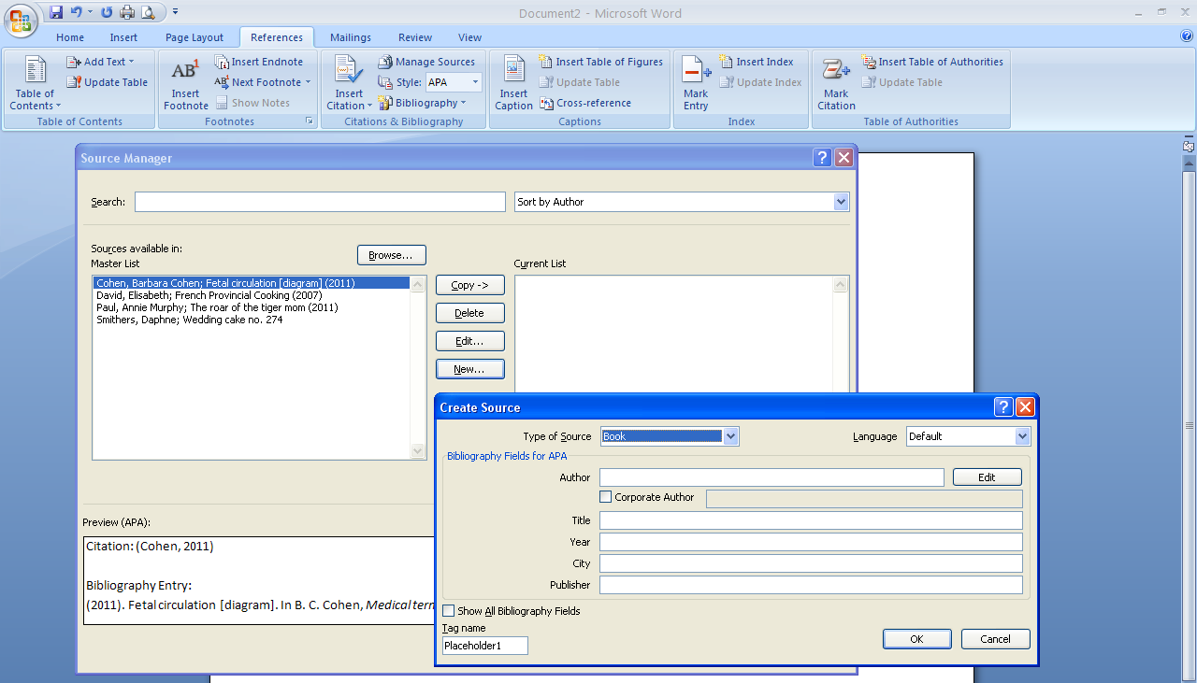
Exercise: click on a few of the different types eg: book, journal, website. Notice how the list of fields you are given to fill out change for each item.

This is an example of a book entry. The section at the bottom of the dialogue box changes as you click into each field. It gives a sample of how each field should be filed out. There is at least one exception, due to recent updates of APA referencing – you need to add the COUNTRY as well as the CITY for all entries not published in USA. E.g. London, England. You also need to include the STATE if the item is published in USA. It should be in shortened form eg N.Y., Min. You can find a list on http://www.stateabbreviations.us/
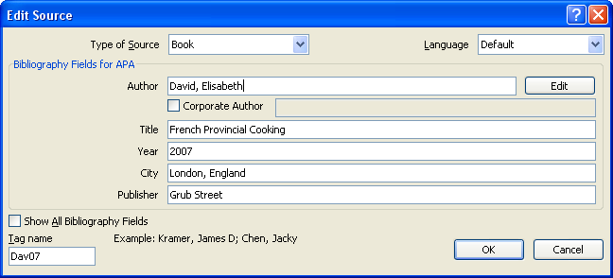

Find a book, click References|New Book and enter the details into the fields. Click OK and the item will be entered into the Master list as well as the current list.
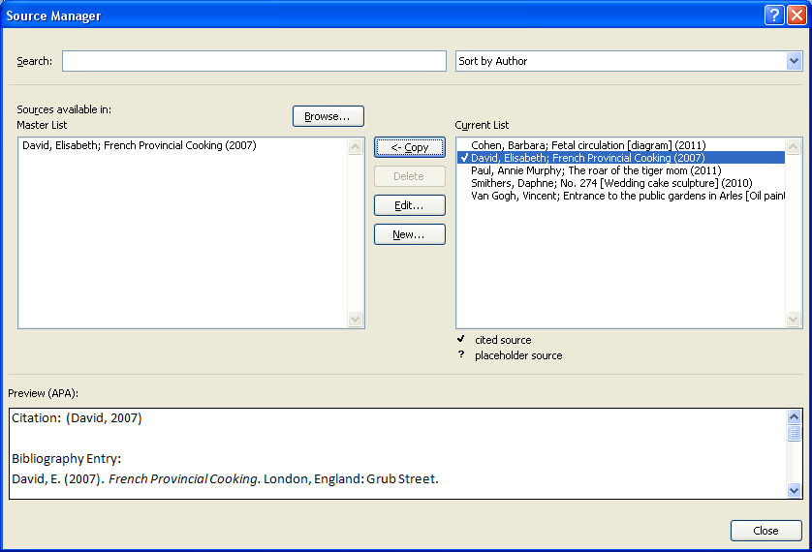
The lower half of the Source Manager box now shows a Preview of how your entry will look in APA format.
The Citation is an example of how the entry will look in the text of your essay. It is short, so that it doesn’t interrupt the flow of reading. However Word doesn’t add pages and para numbers, so you need to remember to edit them in.
The Bibliography entry is an example of how the item will look in your reference list.
Exercise: Pretend you have written a book, and enter it into your bibliography. You will need to decide what it is called, when you wrote it, who published it and where. This information can be entirely imaginary or can have some elements of truth, and don’t forget to add your country of publication!
If you have more than one author, separate the names with a semicolon (;). If you have more than six authors, (all separated by semicolons) the citation will show with the first author, then et al
For example (Alston, et al., 2002).

To add a magazine article, select New/Article in a periodical and fill in the fields:
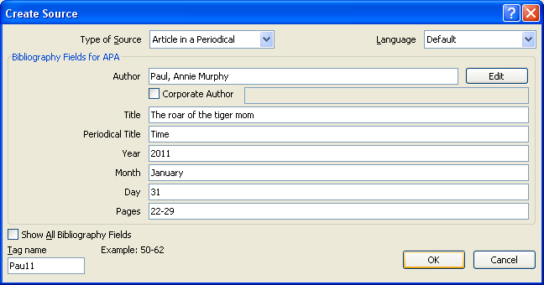
You might be unsure whether the magazine is a Journal or a periodical. If in doubt, fill out as many fields as you can….. remember the idea of referencing is enable the reader to locate the item.

You might need to click on the box show all Bibliography Fields to include more data. Use the scroll bar to move up and down between the data fields. Click OK to save.
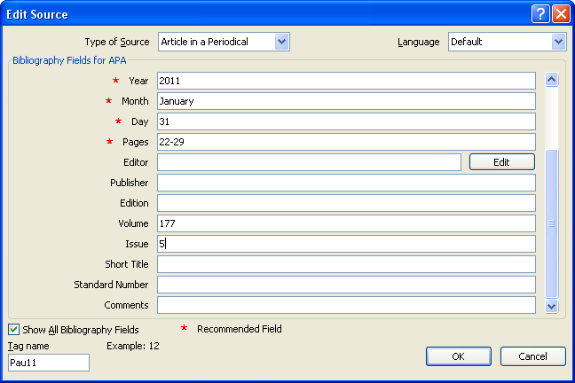

The entry and preview looks as follows:
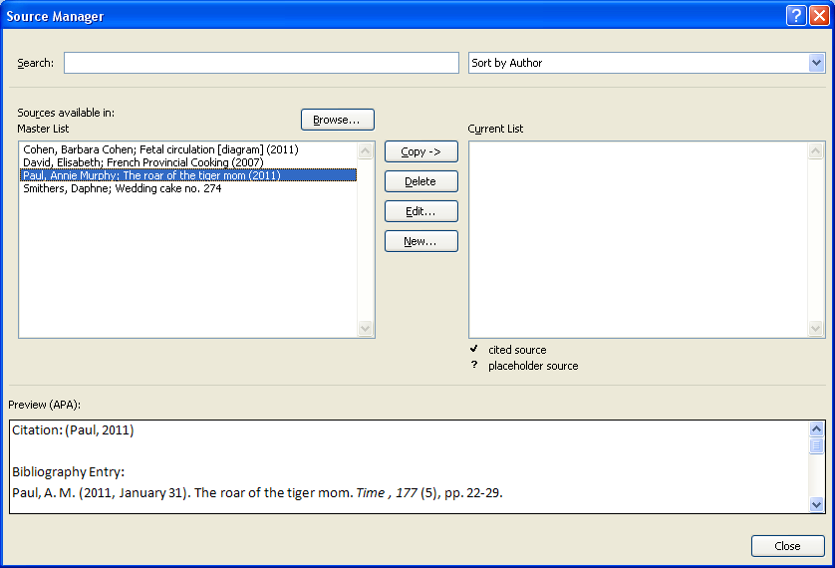

To reference a chart, map, graph, table or diagram, treat it as a section in a book. Choose Book section and fill out the fields listed. The most important part of this entry is to remember to add the type of picture it is in square brackets after the title eg [chart] [diagram] [map].
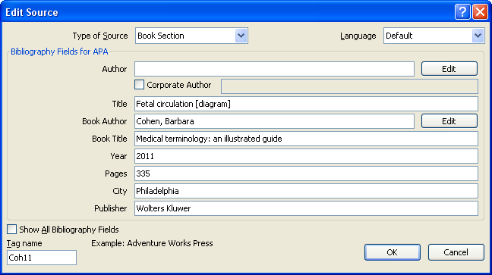

The entry looks as follows:
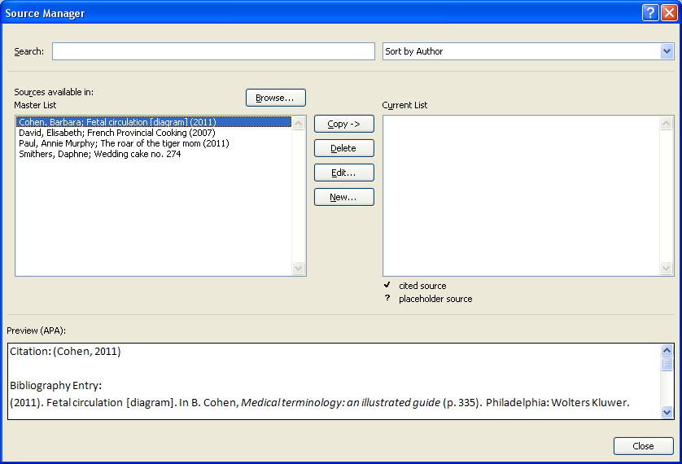

For websites, remember to add the word “website” at the end of your entry in the Name of Web Site field.
The fastest and most accurate way of adding the URL is to copy and paste it from the website into the URL field.
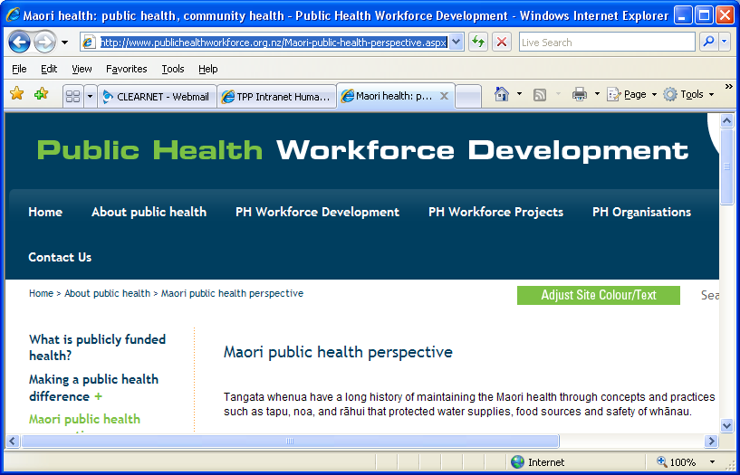

Another source you might find useful is Interview. Remember that the Interviewee is the person giving a reply to questions asked by the interviewer.
If you are the one asking questions, you are the interviewer!
The title in this case would be one that you choose, that gives the reader some idea what the interview is about. For example, “Interview with Chris Booth on recent sculptural practices”, or “Interview with Mary Brown on selection of play equipment for under 5’s”.

For a work of art, how it is referenced depends on where you have seen it, and whether it was the original. If you have seen the original work itself, use art. An important point to note is that word doesn’t include year as a Recommended Field, so you need to add it clicking on the box show all bibliography fields, and also add it into the reference list entry manually. As this example cites the original work, Publication title is not required.
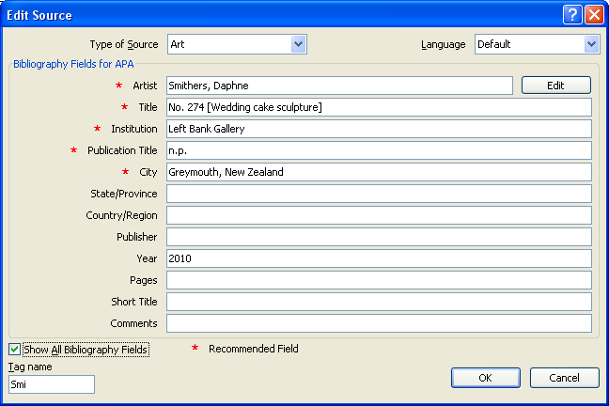
If you have seen an artwork as a reproduction in a book, you need to include information about the book as well. You also need to include the page number, and the slide or figure number if applicable.
This version of Word doesn’t manage this type of work particularly well – using the entry for book section gives the most flexibility and needs the least additional editing.
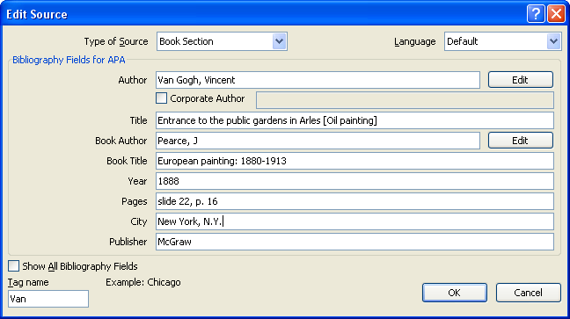
Your entry looks like this:
Cohen, B. (2011). Fetal circulation [diagram]. In B. Cohen, Medical terminology: an illustrated guide (p. 335). Philadelphia: Wolters Kluwer.
David, E. (2007). French Provincial Cooking. London, England: Grub Street.
Ministry of Health. (n.d.). Maori public health perspective. Retrieved February 15, 2010, from Public Health Workforce Development website: http://www.publichealthworkforce.org.nz/Maori-public-health-perspective.aspx
Paul, A. M. (2011, January 31). The roar of the tiger mom. Time, 177(5), pp. 22-29.
Smithers, D. No. 274 [Wedding cake sculpture]. n.p. Left Bank Gallery, Greymouth, New Zealand.
Van Gogh, V. (1888). Entrance to the public gardens in Arles [Oil painting]. In J. Pearce, European painting: 1880-1913 (pp. slide 22, p. 16). New York, N.Y.: McGraw.
Your entry will need to be edited to include where the work is from (collection and city, if available)the date the book was published, and removal of the extra puncuation:
Cohen, B. (2011). Fetal circulation [diagram]. In B. Cohen, Medical terminology: an illustrated guide (p. 335). Philadelphia: Wolters Kluwer.
David, E. (2007). French Provincial Cooking. London, England: Grub Street.
Ministry of Health. (n.d.). Maori public health perspective. Retrieved February 15, 2010, from Public Health Workforce Development website: http://www.publichealthworkforce.org.nz/Maori-public-health-perspective.aspx
Paul, A. M. (2011, January 31). The roar of the tiger mom. Time, 177(5), pp. 22-29.
Smithers, D. No. 274 [Wedding cake sculpture]. n.p. Left Bank Gallery, Greymouth, New Zealand.
Van Gogh, V. (1888). Entrance to the public gardens in Arles [Oil painting]. In J. Pearce, European painting: 1880-1913 (pp. slide 22, p. 16). New York, N.Y.: McGraw.

Where you have a number of images of artworks in your text, they need clear identification. Using Figure 1, Figure 2 etc is a good way to manage this.
Using insert caption keeps the table of figures “live” and means it can be updated automatically.
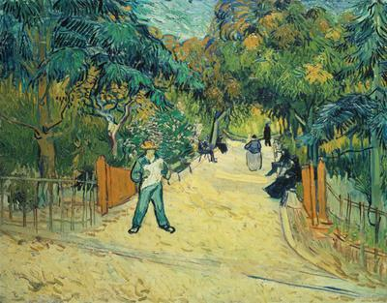
Figure 1. Van Gogh, 1888, Entrance to the public gardens at Arles.

To add citations
Click on insert citation and select from the list that drops down
If the item you wish to cite is not on the list, you can click on add new source, this takes you back into the dialogue box you see when managing sources. It is just a different way of getting there. When you select a citation from the list, it adds it to the text and looks like this (David, 2007). That reference is then marked in your source list with a tick.
If you hover the cursor over the citation you will notice it becomes shaded.
Yu are able to edit the citation by clicking on the shaded area. A drop down box and a list of options appear. You can use this to add page numbers. If your course requires you to add () in a different place than is added automatically, you might prefer to add the citations manually, or to convert it to static text and adjust the position of the brackets.
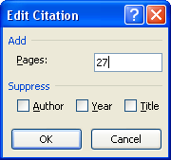
eg the live, automatic citation (David, 2007, p. 27) converted to static text allows it to be changed to David (2007, para. 3, p. 27)

Once you have completed your essay, go into manage sources and remove items on the current list that are not marked with a tick.
Doing this means that when you generate your bibliography list, it only includes items that you have referenced. To insert a list at the end of your document, click Bibliography and then insert bibliography
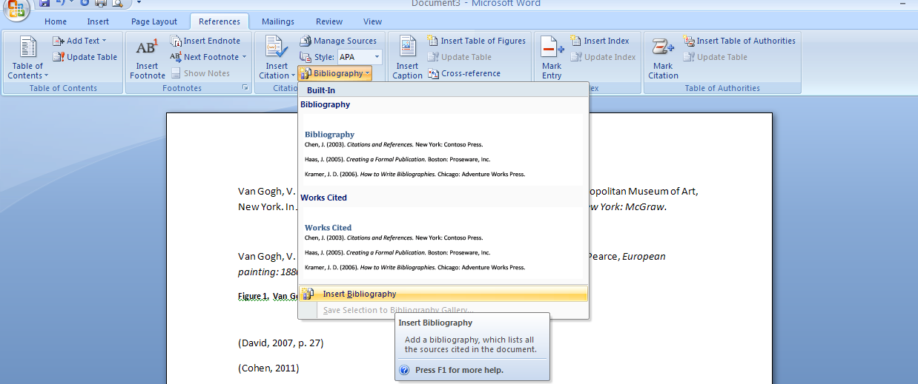
It should look something like this:
Cohen, B. (2011). Fetal circulation [diagram]. In B. Cohen, Medical terminology: an illustrated guide (p. 335). Philadelphia: Wolters Kluwer.
David, E. (2007). French Provincial Cooking. London, England: Grub Street.
Ministry of Health. (n.d.). Maori public health perspective. Retrieved February 15, 2010, from Public Health Workforce Development website: http://www.publichealthworkforce.org.nz/Maori-public-health-perspective.aspx
Paul, A. M. (2011, January 31). The roar of the tiger mom. Time, 177(5), pp. 22-29.
Smithers, D. No. 274 [Wedding cake sculpture]. n.p. Left Bank Gallery, Greymouth, New Zealand.
Van Gogh, V. (1888). Entrance to the public gardens in Arles [Oil painting]. In J. Pearce, European painting: 1880-1913 (pp. slide 22, p. 16). New York, N.Y.: McGraw.
Cohen, B. (2011). Fetal circulation [diagram]. In B. Cohen, Medical terminology: an illustrated guide (p. 335). Philadelphia: Wolters Kluwer.
David, E. (2007). French Provincial Cooking. London, England: Grub Street.
Ministry of Health. (n.d.). Maori public health perspective. Retrieved February 15, 2010, from Public Health Workforce Development website: http://www.publichealthworkforce.org.nz/Maori-public-health-perspective.aspx
Paul, A. M. (2011, January 31). The roar of the tiger mom. Time, 177(5), pp. 22-29.
Smithers, D. No. 274 [Wedding cake sculpture]. n.p. Left Bank Gallery, Greymouth, New Zealand.
Van Gogh, V. (1888). Entrance to the public gardens in Arles [Oil painting]. In J. Pearce, European painting: 1880-1913 (pp. slide 22, p. 16). New York, N.Y.: McGraw.

Formatting your reference list
You are able to select the entire list and change the font if required to do so by your tutors. You may also be required to use a hanging Indent format – to do this, select your list, go to Home|paragraph and in the Paragraph dialogue box Special|Hanging

It will convert to look like this:
Cohen, B. (2011). Fetal circulation [diagram]. In B. Cohen, Medical terminology: an illustrated guide (p. 335). Philadelphia: Wolters Kluwer.
David, E. (2007). French Provincial Cooking. London, England: Grub Street.
Ministry of Health. (n.d.). Maori public health perspective. Retrieved February 15, 2010, from Public Health Workforce Development website: http://www.publichealthworkforce.org.nz/Maori-public-health-perspective.aspx
Paul, A. M. (2011, January 31). The roar of the tiger mom. Time, 177(5), pp. 22-29.
Smithers, D. No. 274 [Wedding cake sculpture]. n.p. Left Bank Gallery, Greymouth, New Zealand.
Van Gogh, V. (1888). Entrance to the public gardens in Arles [Oil painting]. In J. Pearce, European painting: 1880-1913 (pp. slide 22, p. 16). New York, N.Y.: McGraw.
Cohen, B. (2011). Fetal circulation [diagram]. In B. Cohen, Medical terminology: an illustrated guide (p. 335). Philadelphia: Wolters Kluwer.
David, E. (2007). French Provincial Cooking. London, England: Grub Street.
Ministry of Health. (n.d.). Maori public health perspective. Retrieved February 15, 2010, from Public Health Workforce Development website: http://www.publichealthworkforce.org.nz/Maori-public-health-perspective.aspx
Paul, A. M. (2011, January 31). The roar of the tiger mom. Time, 177(5), pp. 22-29.
Smithers, D. No. 274 [Wedding cake sculpture]. n.p. Left Bank Gallery, Greymouth, New Zealand.
Van Gogh, V. (1888). Entrance to the public gardens in Arles [Oil painting]. In J. Pearce, European painting: 1880-1913 (pp. slide 22, p. 16). New York, N.Y.: McGraw.

For more information see Pocket guide to APA style by Robert Perrin (held at 808.06615 PER)
Glossary
Bibliography – this is an alphabetical list that contains the items that you have read while researching for your essay, but that you have not cited. It is useful to start by adding details for all of the items you are reading, as ideas change as you write and there is nothing quite so frustrating as not being able to find out where you got an idea from. Don’t forget to record the page numbers as you go!!
Current list – a list of the items you have added to the current document. You are able to copy these into your master list if required.
Journal – original research that is peer reviewed eg Journal of Heritage Tourism
Master list – a list of all your bibliographical records. If you are working at one computer, the master list will transfer into any new document you open. However if you are changing computers, only the items in the current list of that document will be listed when you open it.
Paraphrase – rewriting an idea using your own words
Peridocial – a magazine that is published at regular intervals eg Time, Cuisine
Reference list – this is an alphabetical list that only contains the items you have cited (or referenced) in your essay. Some courses require BOTH a reference list and a bibliography.

