### Teaching and Learning Workshop

**Two days:** Monday 2 February - Tuesday 3 February 2014

* Introduction to some teaching strategies that support active learning.
* Planning and feedback strategies to support learning.
* Developing students who are 'expert' learners.
* The mysterious matter of student motivation.
* Teaching methodologies relevant to Maori learners.
* Introduction to assessment.

For any more details, please check the Professional Development Calendar site on Moodle. There is a temporary enrolment code on the site for those creating new accounts. It is ***marshmellow***.

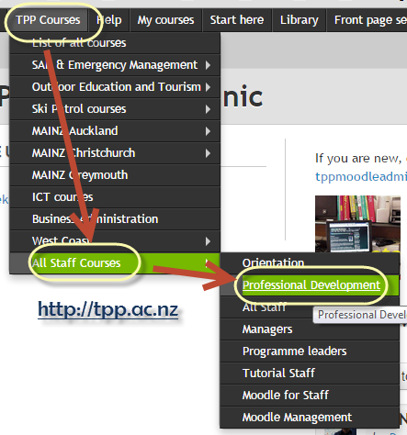

#### Student learning skills

Looking ahead to 2015.

Developing in our students habits around self directed learning (including adequate planning and organisation skills) is quite a challenge.

If you are interested in trying something intentional along this line, or if you have some Ideas you are interested in sharing, please contact me.

We may have a brief VC meetup next week on Wednesday if there is interest.